**NAAN MUDHALVAN PROJERCT REPORT**

**ON**

**“Intelligent Customer Retention Using Machine Learning for Enhanced Prediction of Telecom Customer Churn”**

Submitted in partial fulfillment of the requirements for the award of the degree of

**Bachelor of Science**

**In**

**Computer Science**

Submitted By

**Team Leader**

**Mathavi S** (Reg.No:20201371506118)

**Team Members**

**Indhuja A (Reg.No:20201371506108)**

**Priyadharshini C (Reg.No:20201371506126)**

**Sivaranjani G (Reg.No:20201371506137)**



Department of Computer Science

Government Arts and Science College for Women, Alangulam

Tenkasi-627 851

April-2023

Intelligent Customer Retention Using Machine Learning for Enhanced Prediction of Telecom Customer Churn

1:INTRODUCTION

Intelligent Customer Retention using Machine Learning is an approach that has been adopted by telecom companies to predict customer churn and take proactive measures to retain customers.

Overview

Machine learning algorithms are used to analyze customer data, such as usage patterns, customer demographics, and other relevant factors.

These algorithms then generate predictive models that help identify customers who are likely to churn. This information can be used to develop targeted retention strategies, such as personalized offers or proactive customer support.

It allows telecom companies to analyze large amounts of data quickly and accurately, identify trends and patterns that may be missed by human analysts, and provide real-time insights into customer behaviour.

**Purpose**

The objective is to predict which customers are likely to churn in the near future, so that companies can take proactive measures to prevent them from leaving.

The use of machine learning algorithms enables telecom companies to analyze vast amounts of customer data and generate predictive models that can help identify customers who are likely to churn.

The main goal of using Intelligent Customer Retention using Machine Learning is to improve the overall customer experience and satisfaction.

2:Problem Definition &Design Thinking

Empathy Map

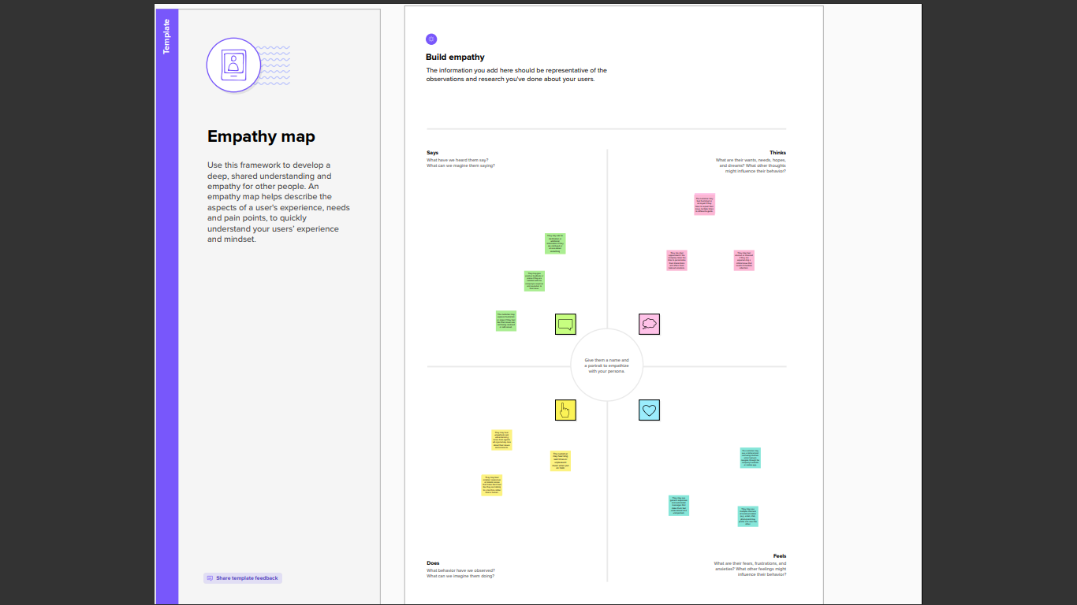

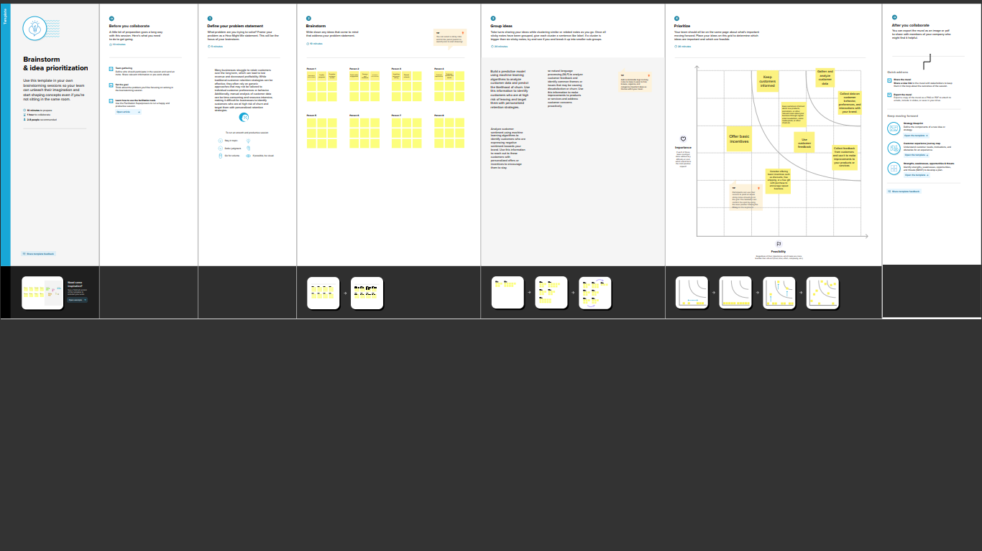Ideation and Brainstorming Map:

3:Result

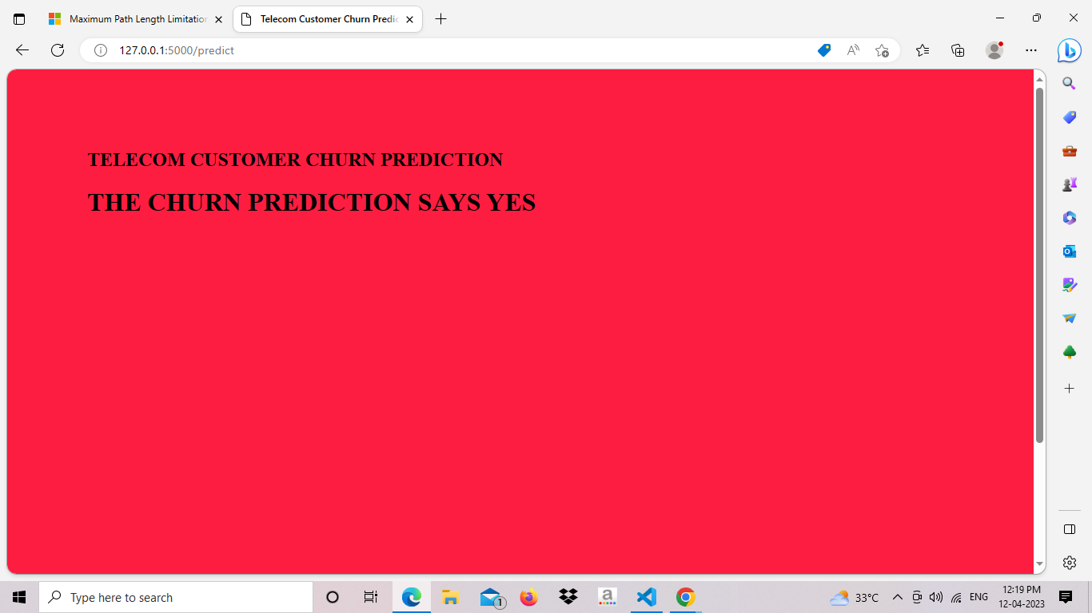

4:ADVANTAGES & DISADVANTAGES

Improved Accuracy: Machine learning algorithms can analyze large amounts of data and identify patterns and trends that may be missed by human analysts, leading to more accurate predictions of customer churn

Personalization: Machine learning allows companies to develop personalized retention strategies tailored to individual customers, improving the overall customer experience and increasing the likelihood of retaining customers.

Real-time insights: Machine learning enables companies to analyze data in real-time, providing real-time insights into customer behavior and enabling companies to take proactive measures to retain customers.

Data quality: The accuracy of the predictions generated by machine learning algorithms depends on the quality of the data. Poor quality data can lead to inaccurate predictions and ineffective retention strategies.

Over-reliance on technology: Over-reliance on machine learning algorithms can lead to a loss of human judgment, leading to ineffective retention strategies.

Complexity: The use of machine learning can be complex, requiring expertise and resources that may be beyond the reach of some companies.

5:APPLICATION

Product Development: Machine learning can be used to analyze customer feedback and usage patterns to develop new products and services that meet the specific needs and preferences of customers.

Customer Lifetime Value Prediction: Machine learning can be used to predict the lifetime value of customers, which helps companies prioritize their retention efforts and allocate resources to retain high-value customers.

6:CONCLUSION

The use of Intelligent Customer Retention using Machine Learning provides several benefits, such as reducing the time and cost required to analyze customer data, improving the accuracy of churn predictions, and enabling companies to develop targeted retention strategies that are tailored to individual customers.

7:FUTURE SCOPE

Integration with other technologies: Intelligent Customer Retention using Machine Learning can be integrated with other technologies such as artificial intelligence, big data, and the Internet of Things (IoT) to further enhance customer retention strategies and increase profitability.

Real-time analytics: Real-time analytics can be used to provide instant insights into customer behavior, allowing companies to take immediate actions to retain customers and prevent churn.

8:APPENDIX

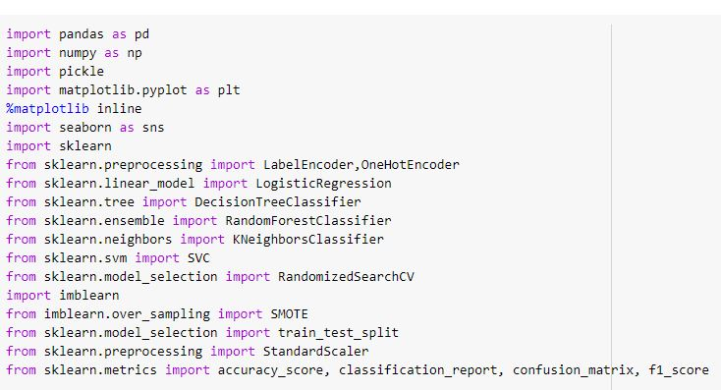



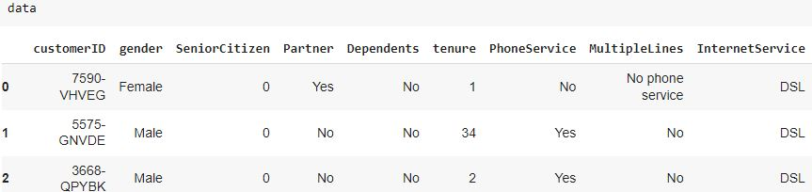

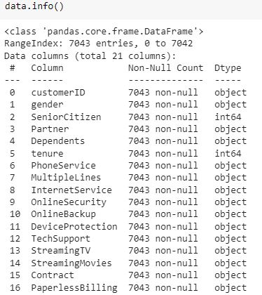

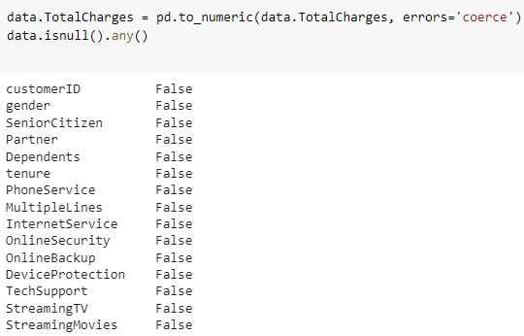



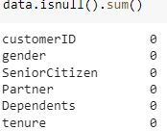

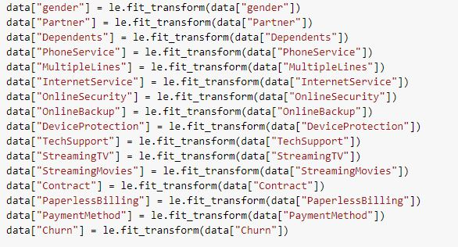

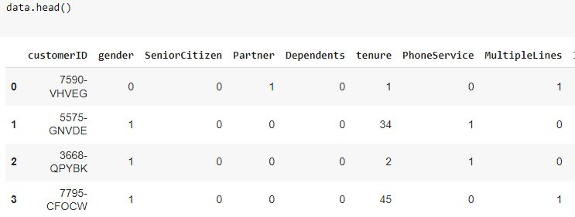



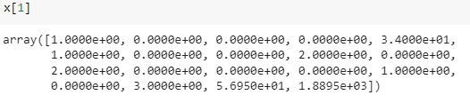

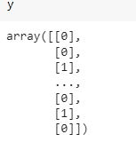

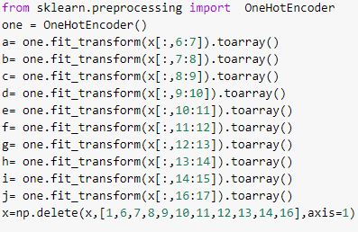

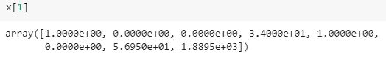









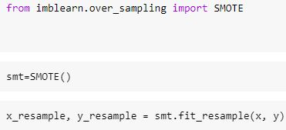

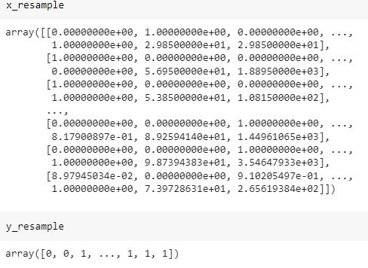

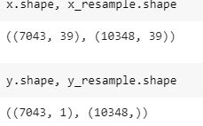

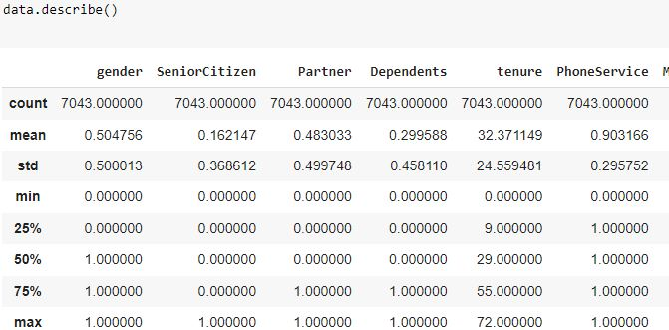

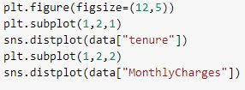

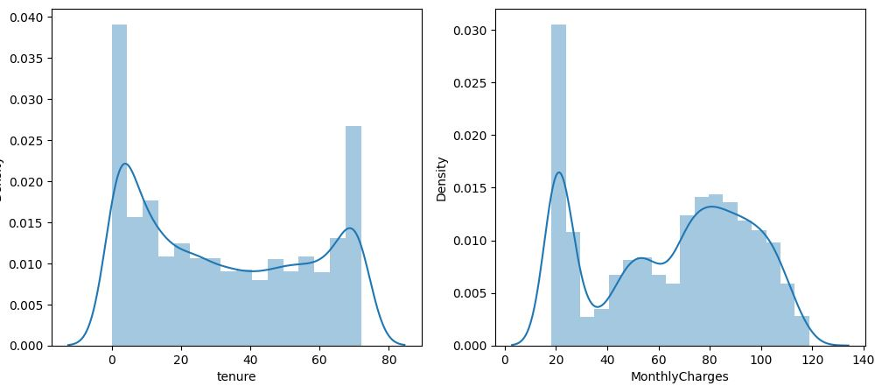

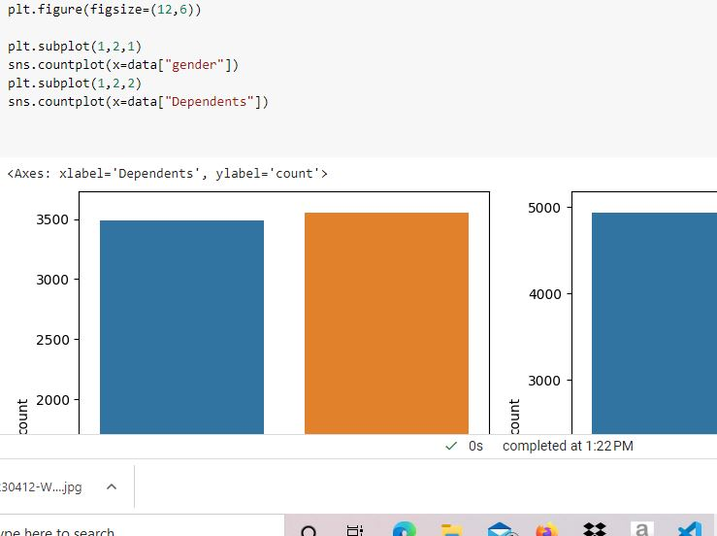

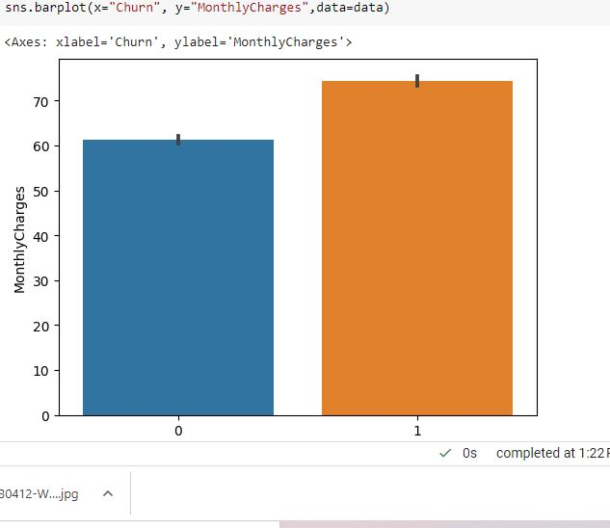

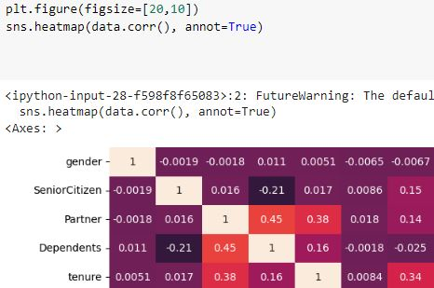

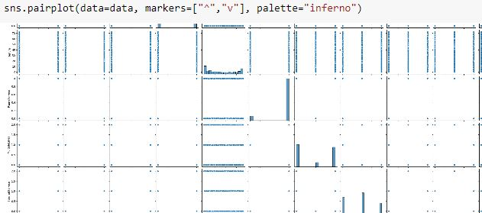

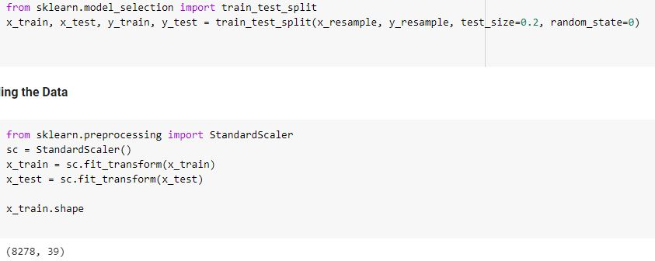

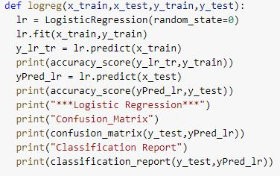

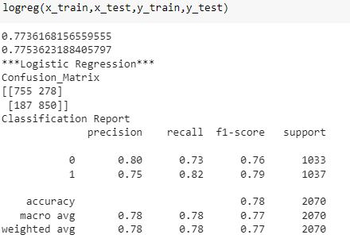

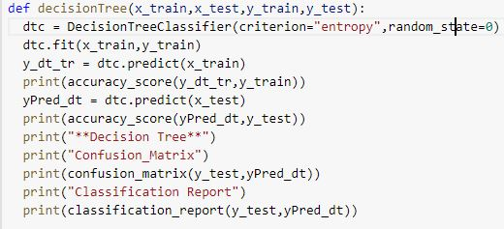





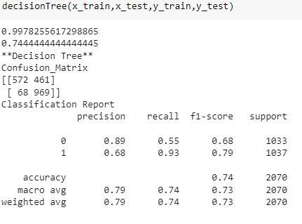

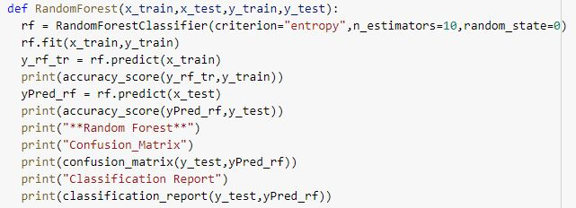

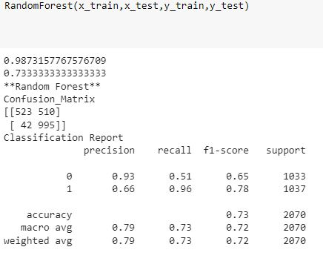

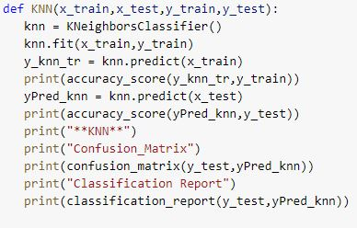

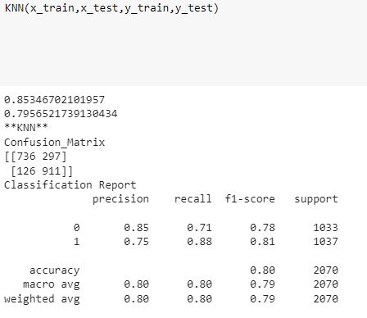

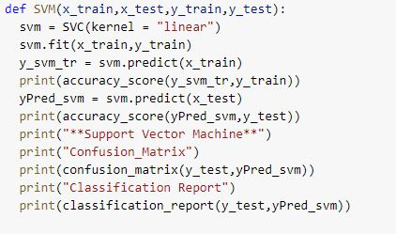

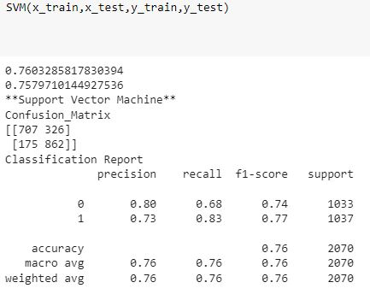

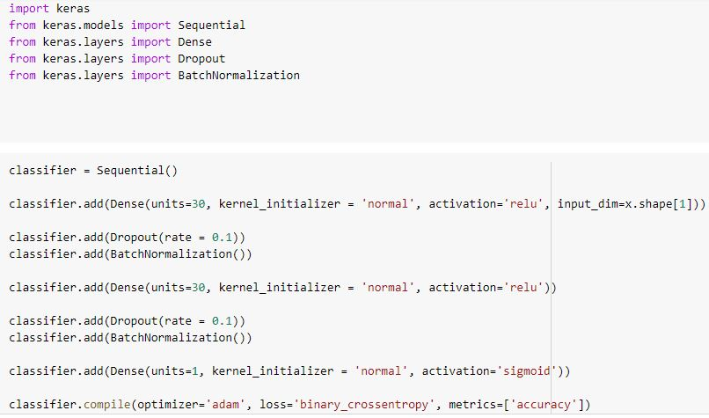

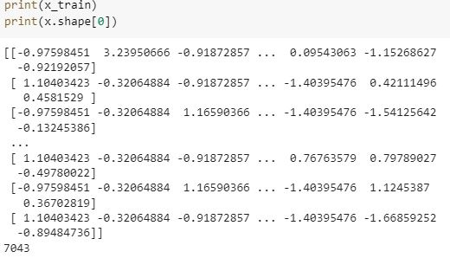

3